**\*Pointer To One Structure Variable\***

**Name:Ravi Prakash Zanke.**

**Proff.: Vinayak Sir.**

**Topic: Pointer To One Structure Variable.**

**Assignment Date:24/04/23**

**<………………………………………………………………………………………………………………..>**

**1.Student.**

#include<stdio.h>

#include<string.h>

typedef struct student

{

char name[50];

char gender[50];

float marks;

int rollnum;

}student;

void store(student*);

void display(student*);

void main()

{

student s1;

store(&s1);

display(&s1);

}

void store(student* s1)

{

int i;

puts("........Hey Answer The Below Question.........");

puts("........................................................................");

printf("Enter Name of The Student :");

scanf("%s",&s1->name);

fflush(stdin);

printf("Enter Roll Number of Student :");

scanf("%d",&s1->rollnum);

printf("Enter Gender of Student :");

scanf("%s",&s1->gender);

fflush(stdin);

printf("Enter Marks of Student :");

scanf("%f",&s1->marks);

fflush(stdin);

}

void display(student* a)

{

puts("\n Hey ur Entered Details are");

puts("........................................................................");

printf("Student Name :%s",a->name);

printf("\nStudent Roll number :%d",a->rollnum);

printf("\nStudent Gender :%s",a->gender);

printf("\nStudent Marks :%.2f %%",a->marks);

}

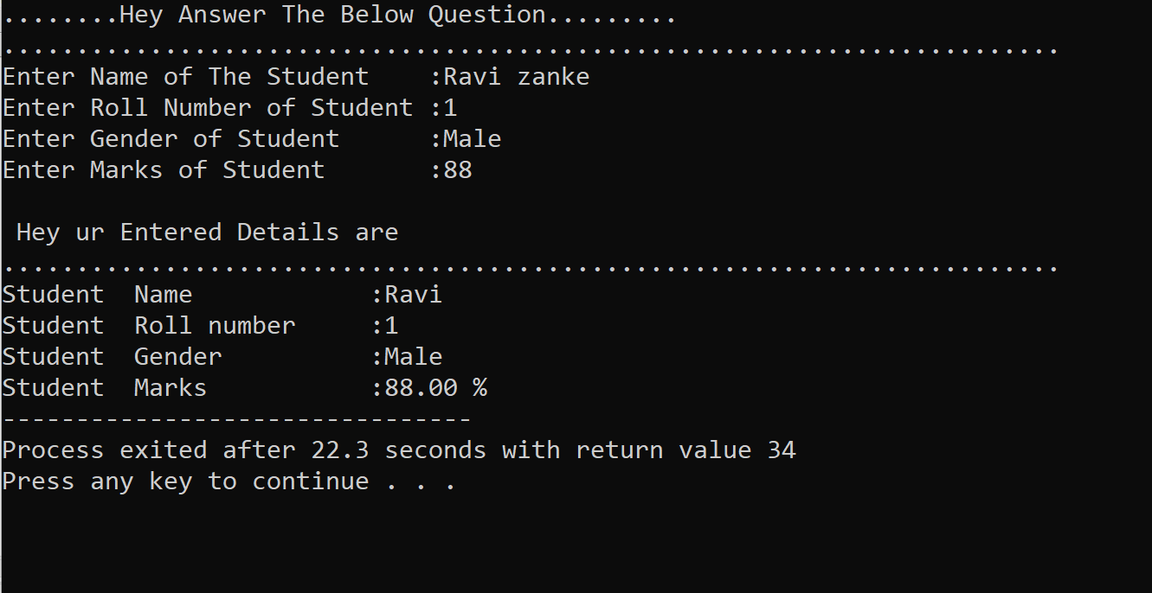

**<………………………………………………………………………………………………………………..>**

**2.Employ.**

#include<stdio.h>

#include<string.h>

typedef struct employ

{

char name[50];

int id;

double salary;

}employ;

void store(employ*);

void display(employ*);

void main()

{

employ e1;

store(&e1);

display(&e1);

}

void store(employ* e1)

{

puts("........Hey Answer The Below Question.........");

puts("........................................................................");

printf("Enter Name of The Employ :");

scanf("%s",&e1->name);

fflush(stdin);

printf("Enter Id Number of Employ :");

scanf("%d",&e1->id);

printf("Enter Salary of Employ :");

scanf("%lf",&e1->salary);

fflush(stdin);

}

void display(employ* a)

{

puts("\n Hey ur Entered Details are");

puts("........................................................................");

printf("Employ Name :%s",a->name);

printf("\nEmploy Id number :%d",a->id);

printf("\nEmploy salary :%.2lf Rupees/month /-",a->salary);

}

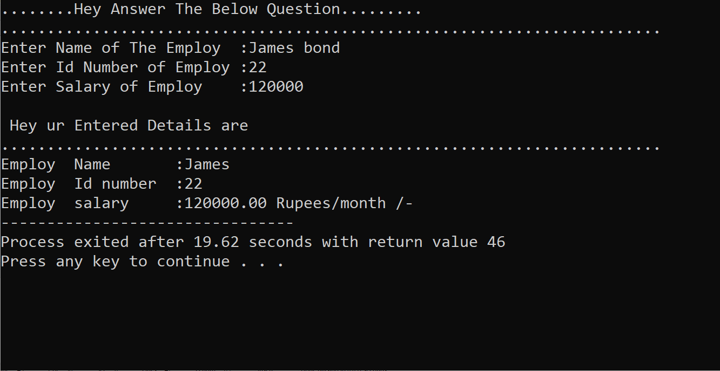

**<………………………………………………………………………………………………………………..>**

**3.Sales Manager.**

#include<stdio.h>

#include<string.h>

typedef struct SalesManager

{

char name[50];

int id;

double salary;

double incentive;

int target;

}SalesManager;

void store(SalesManager*);

void display(SalesManager*);

void main()

{

SalesManager sm1;

store(&sm1);

display(&sm1);

}

void store(SalesManager* sm1)

{

puts("........Hey Answer The Below Question.........");

puts("........................................................................");

printf("Enter Name of The Sales Manager :");

gets(&sm1->name);

fflush(stdin);

printf("Enter Id Number of Sales Manager :");

scanf("%d",&sm1->id);

printf("Enter Salary of Sales Manager :");

scanf("%lf",&sm1->salary);

printf("Enter Incentives of Sales Manager :");

scanf("%lf",&sm1->incentive);

printf("Enter Targetof Sales Manager :");

scanf("%d",&sm1->target);

}

void display(SalesManager* a)

{

puts("\n Hey ur Entered Details are");

puts("........................................................................");

printf("Sales Manager Name :%s",a->name);

printf("\nSales Manager Id number :%d",a->id);

printf("\nSales Manager salary :%.2lf Rupees/Months /-",a->salary);

printf("\nSales Manager Incentive :%.2lf Rupees/Months /-",a->incentive);

printf("\nSales Manager Target :%d",a->target);

}

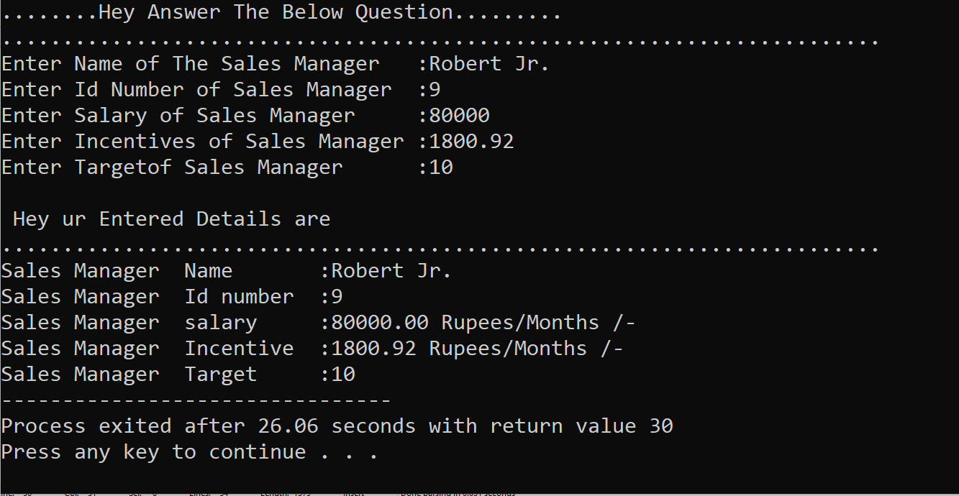

**<………………………………………………………………………………………………………………..>**

**4.Admin.**

#include<stdio.h>

#include<string.h>

typedef struct Admin

{

char name[50];

int id;

double salary;

double allowance;

}Admin;

void store(Admin*);

void display(Admin*);

void main()

{

Admin a1;

store(&a1);

display(&a1);

}

void store(Admin* a1)

{

puts("........Hey Answer The Below Question.........");

puts("........................................................................");

printf("Enter Name of The Admin :");

scanf("%s",&a1->name);

fflush(stdin);

printf("Enter Id Number of Admin :");

scanf("%d",&a1->id);

printf("Enter Salary of Admin :");

scanf("%lf",&a1->salary);

printf("Enter Allowances of Admin :");

scanf("%lf",&a1->allowance);

fflush(stdin);

}

void display(Admin* a)

{

puts("\n Hey ur Entered Details are");

puts("........................................................................");

printf("Admin Name :%s",a->name);

printf("\nAdmin Id number :%d",a->id);

printf("\nAdmin salary :%.2lf Rupees/Month /-",a->salary);

printf("\nAdmin Allowance :%.2lf Rupees/Month /-",a->allowance);

}

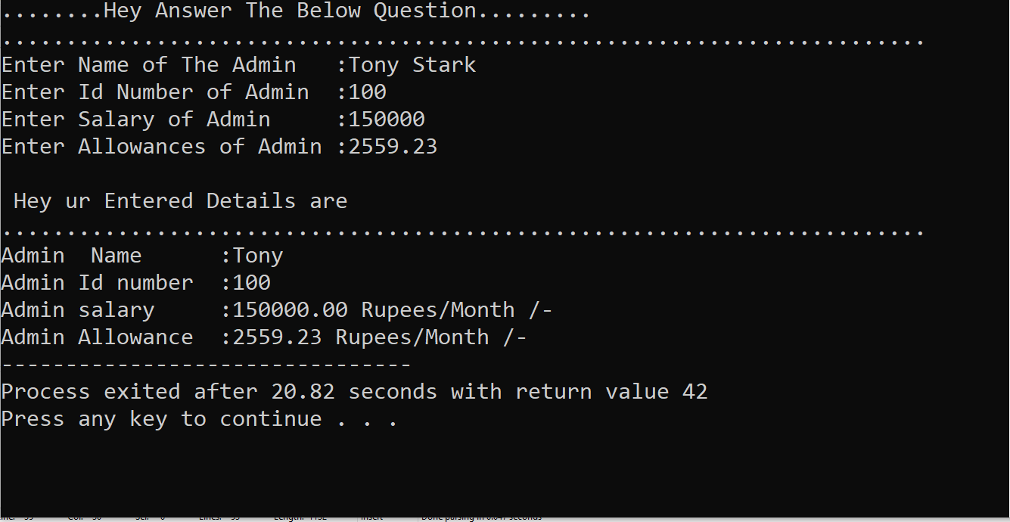

**<………………………………………………………………………………………………………………..>**

**5.HR.**

#include<stdio.h>

#include<string.h>

typedef struct HR

{

char name[50];

int id;

double salary;

double commission;

}HR;

void store(HR*);

void display(HR*);

void main()

{

HR hr1;

store(&hr1);

display(&hr1);

}

void store(HR* hr1)

{

puts("........Hey Answer The Below Question.........");

puts("........................................................................");

printf("Enter Name of The HR :");

scanf("%s",&hr1->name);

fflush(stdin);

printf("Enter Id Number of HR :");

scanf("%d",&hr1->id);

printf("Enter Salary of HR :");

scanf("%lf",&hr1->salary);

printf("Enter Commission of HR :");

scanf("%lf",&hr1->commission);

fflush(stdin);

}

void display(HR* a)

{

puts("\n Hey ur Entered Details are");

puts("........................................................................");

printf("HR Name :%s",a->name);

printf("\nHR Id number :%d",a->id);

printf("\nHR salary :%.2lf Rupees/Month /-",a->salary);

printf("\nHR Commission :%.2lf Rupees/Month /-",a->commission);

}

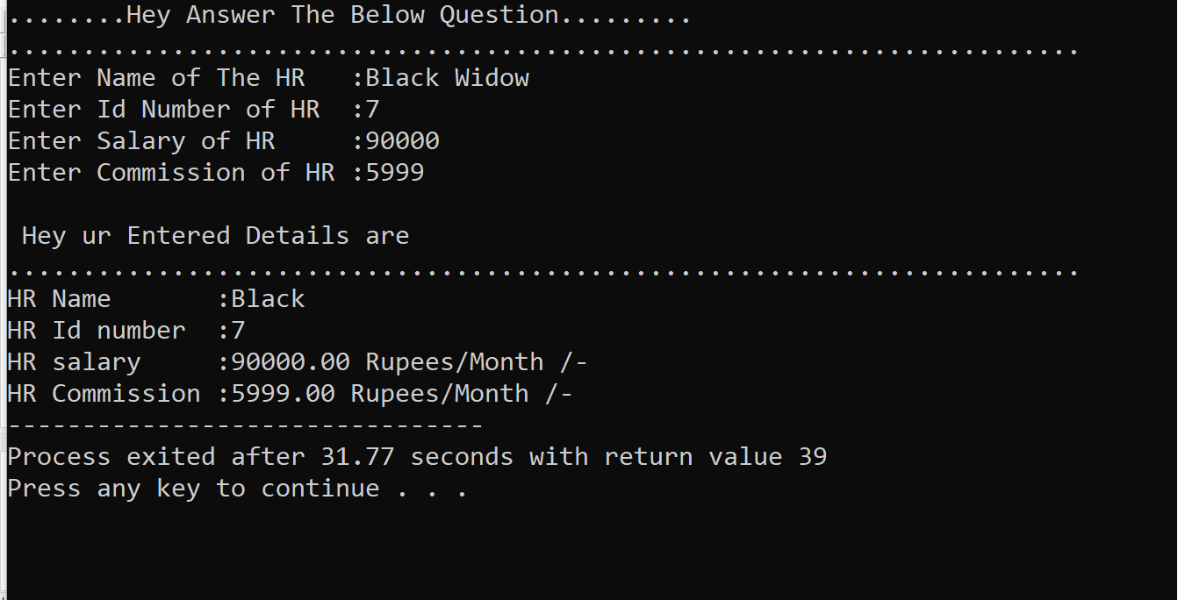

**<………………………………………………………………………………………………………………..>**

**6.Date.**

#include<stdio.h>

#include<string.h>

typedef struct Date

{

int day;

int month;

int year;

}Date;

void store(Date*);

void display(Date*);

void main()

{

Date d1;

store(&d1);

display(&d1);

}

void store(Date* d1)

{

puts("........Hey Answer The Below Question.........");

puts("........................................................................");

printf("Enter Day of The Date :");

scanf("%d",&d1->day);

printf("Enter Month Number of Date :");

scanf("%d",&d1->month);

printf("Enter Year of Date :");

scanf("%d",&d1->year);

fflush(stdin);

}

void display(Date* a)

{

puts("\n Hey ur Entered Details are");

puts("........................................................................");

printf("Day|Month|Year:");

printf("\n %d %d %d",a->day,a->month,a->year);

}

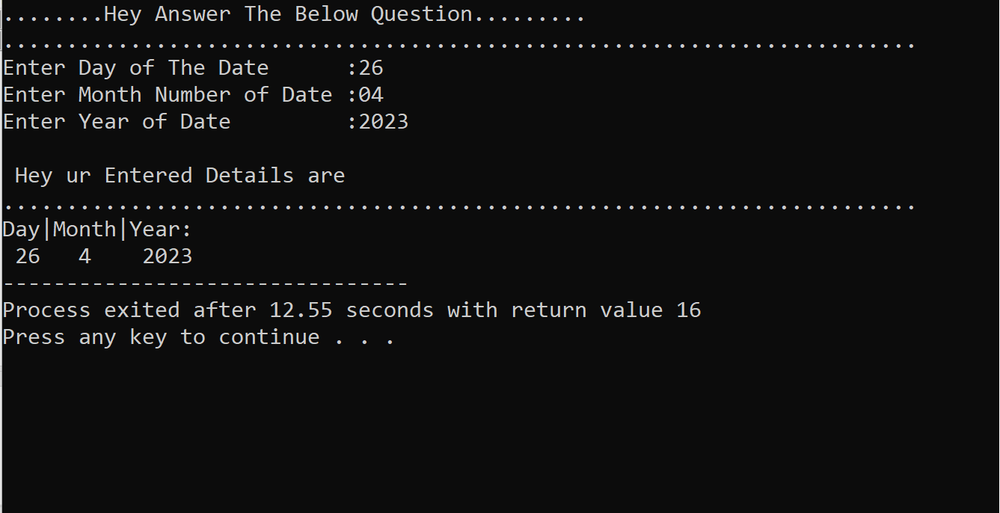

**<………………………………………………………………………………………………………………..>**

**7.Time.**

#include<stdio.h>

#include<string.h>

typedef struct Time

{

int hours;

int mins;

int seconds;

}Time;

void store(Time*);

void display(Time*);

void main()

{

Time t1;

store(&t1);

display(&t1);

}

void store(Time* t1)

{

puts("........Hey Answer The Below Question.........");

puts("........................................................................");

printf("Enter Hours :");

scanf("%d",&t1->hours);

printf("Enter Minutes :");

scanf("%d",&t1->mins);

printf("Enter Seconds :");

scanf("%d",&t1->seconds);

fflush(stdin);

}

void display(Time* a)

{

puts("\n Hey ur Entered Details are");

puts("........................................................................");

printf(" Hours|Minutes|Seconds:");

printf("\n %d %d %d",a->hours,a->mins,a->seconds);

}

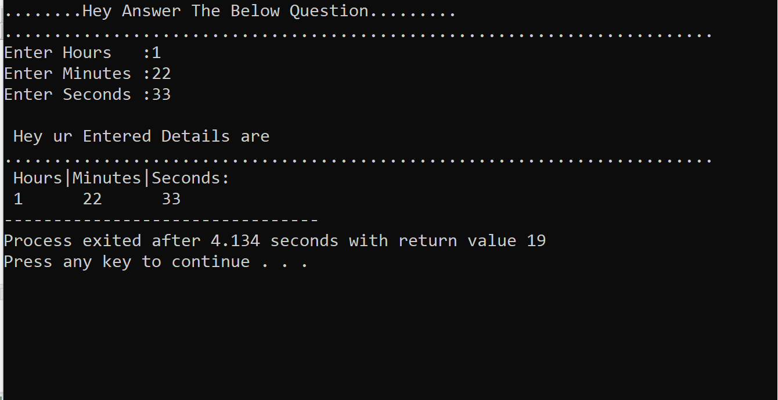

**<………………………………………………………………………………………………………………..>**

**8.Complex Number.**

#include<stdio.h>

#include<string.h>

typedef struct ComplexNumber

{

float real;

float imaginary;

}ComplexNumber;

void store(ComplexNumber*);

void display(ComplexNumber*);

void main()

{

ComplexNumber cn1;

store(&cn1);

display(&cn1);

}

void store(ComplexNumber* cn1)

{

puts("........Hey Answer The Below Question.........");

puts("........................................................................");

printf("Enter Real Number :");

scanf("%f",&cn1->real);

printf("Enter Imaginary Number:");

scanf("%f",&cn1->imaginary);

fflush(stdin);

}

void display(ComplexNumber* a)

{

puts("\n Hey ur Entered Details are");

puts("........................................................................");

printf("The Syntax :(RealNumber)+(ImaginaryNumber)i");

printf("\nYour Equation: %.2f + %.2fi",a->real,a->imaginary);

}

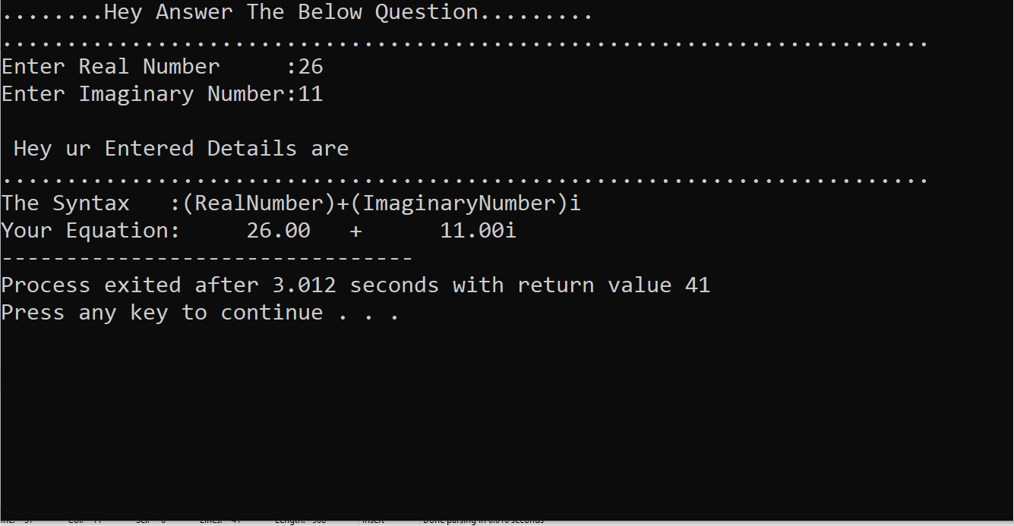

**<………………………………………………………………………………………………………………..>**

**9.Distance.**

#include<stdio.h>

#include<string.h>

typedef struct Distance

{

float feets;

float inches;

}Distance;

void store(Distance*);

void display(Distance*);

void main()

{

Distance d1;

store(&d1);

display(&d1);

}

void store(Distance* d1)

{

puts("........Hey Answer The Below Question.........");

puts("........................................................................");

printf("Enter Number in feet :");

scanf("%f",&d1->feets);

printf("Enter Number in Inches :");

scanf("%f",&d1->inches);

fflush(stdin);

}

void display(Distance* a)

{

puts("\n Hey ur Entered Details are");

puts("\n........................................................................");

printf("Feets|Inches");

printf("\n%.2f | %.2f",a->feets,a->inches);

}

